Homework – solutions

Task . Linear search flowchart

Create a flowchart for a linear search using the following instructions as a guide:

1. Take a list of data and an item that is being searched for (the search item)
2. Repeat steps a-c starting from the first item in the list, until you find the search item or until the end of the list is reached:
   1. Compare the item at the current position to the search item
   2. If the item at the current position is equal to the search item, then stop searching and output “Found”.
   3. Otherwise, go to the next item in the list.

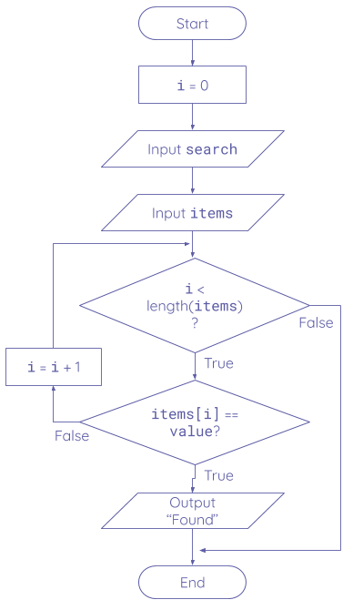

Resources are updated regularly — the latest version is available at: [ncce.io/tcc](http://ncce.io/tcc).

This resource is licensed under the Open Government Licence, version 3. For more information on this licence, see [ncce.io/ogl](http://ncce.io/ogl).